**Question 1:** What is the difference between an abstract class and an interface?

**Question 2: i).** Give an account of advantages and disadvantages of inheritance and composition. **ii).**

Give an example of when inheritance is better and when composition is better

**Advantages:**

|  |  |
| --- | --- |
| Composition | Inheritance |
| Easier to change the interface of back-end classes and front-end classes. | Makes the code easier to change if the needed change involves adding a new subclass, dynamic binding and polymorphism can be used. |
| Allow us to delay the creation of back end objects until they are needed | Easy to build and describe Is-A relationship |

**Disadvantages:**

|  |  |
| --- | --- |
| Composition | Inheritance |
| Composite class cannot use dynamic binding and polymorphism | Super class’s interface changing will cause many modifications |
|  | Encapsulation is fragile |

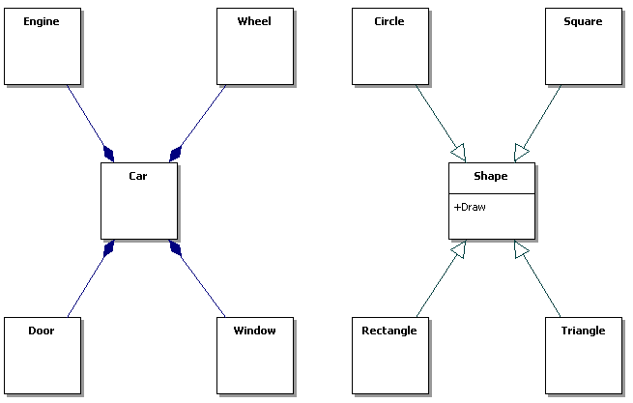

On the left, we want to describe a car system with engine, wheels, doors, etc. We can use composition rather than inheritance to explain and describe the relationship. On the right, it’s better using the inheritance relation to build and implement the system because it shows several obvious “Is-A” relationships and we can easily using the polymorphism here.

**Question 4:** Draw a class diagram for the case of our course. We assume that there are at least the following classes: Person, Student, Instructor and Assistant (you can add as many additional classes as you would like). You should draw associations between them, possible attributes and operations.

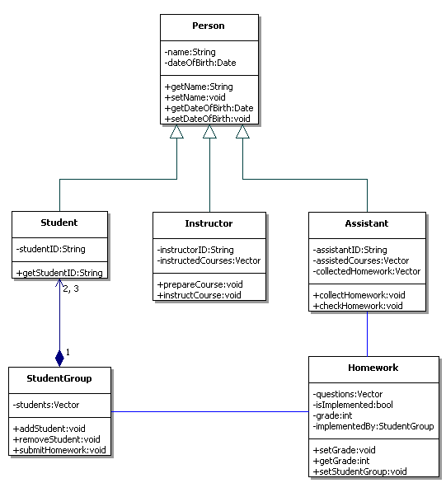

In this diagram, there are 6 basic classes inside, the Student, Instructor and Assistant classes are inherited from Person class, because they are A-Kind-Of person. StudentGroup class is a composite class which consists of 2 to 3 students and the group is responsible for homework. Homework consists of questions and it stored the information about the student group which implements it. Assistant is responsible for collect and check the homework and set the grade. Instructor is responsible for teaching.

**Question 6:** Draw a class diagram for a part of a Car Sharing System, based on a personal interview transcript. Identify any aggregation associations.

***Andres:*** *Just remind me, what kind of things do you need to know about the start and the destination of each journey?*

***Mihhail:*** *We'd want to know the building name and number, the apartment number, the street, town or city, county and postal code or zip code. We'd also want to hold similar information for the home adress of the sharer as well.*

***Andres:*** *OK. Didn't you say that the journey start and destination address will be used to match up possible shared journeys?*

***Mihhail:*** *Yes -interesting point that. I'm not quite sure how you'll do this. We want to be able to establish whether two addresses are close enough to each other to be able to consider them a match for a shared journey. For example, two people may want to get from a start destination on adjacent corners of two different blocks to destination addresses in different floors of the same building. A person looking at the addresses would know that the addresses are similar enough to be a match, but in terms of just text of the addresses, they look completely different.*

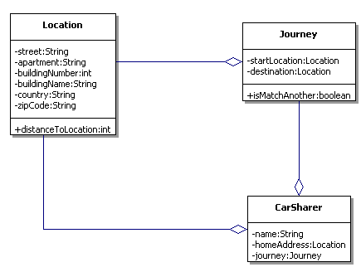

**Question 8:** Draw a sequence diagram of scenario “WarehouseOnFire” given in figure 2-15 in Book.

Include Objects bob, Alice, john, FRIEND and instances of other classes you may need.

**Question 10:** Draw an activity:

"Opening account, deposit/withdraw iterations (with conditions checking) and closing account” as state chart diagram(s).